Git Workflow

This workflow is about how to use GIT command and to add a new project with the usage of GIT.

Steps to follow:

1. Get the access of your project git repository from your project platform section using PROMIS.

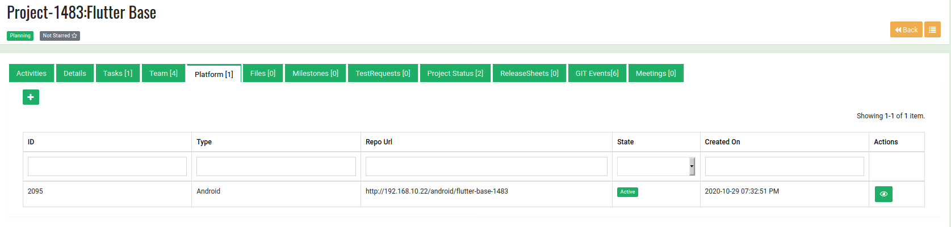

2. Follow the link and open the project repository.

3. Press the clone icon and copy the clone with http URL.

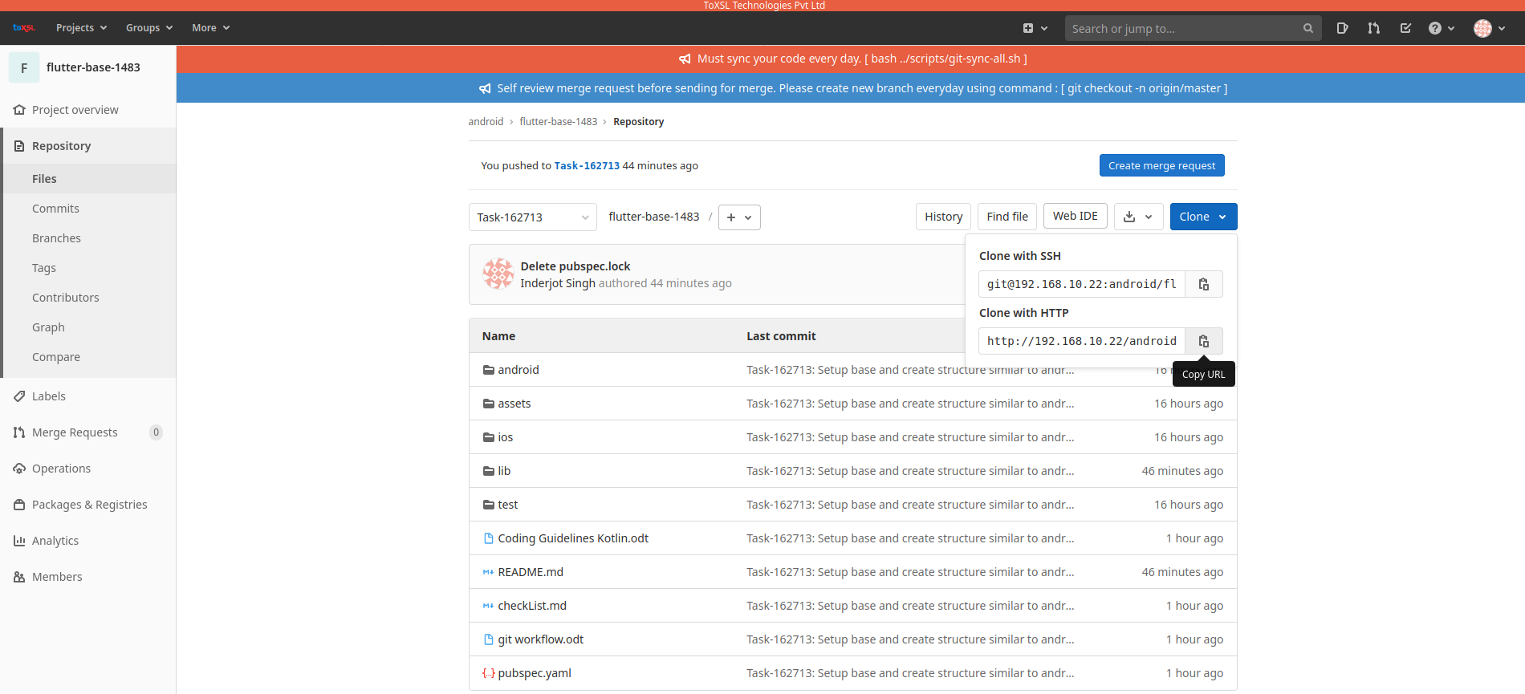

4. open terminal in your workspace and write command mentioned below.

Command: git clone URL or Use command : git clone -b <BRANCHNAME> URL

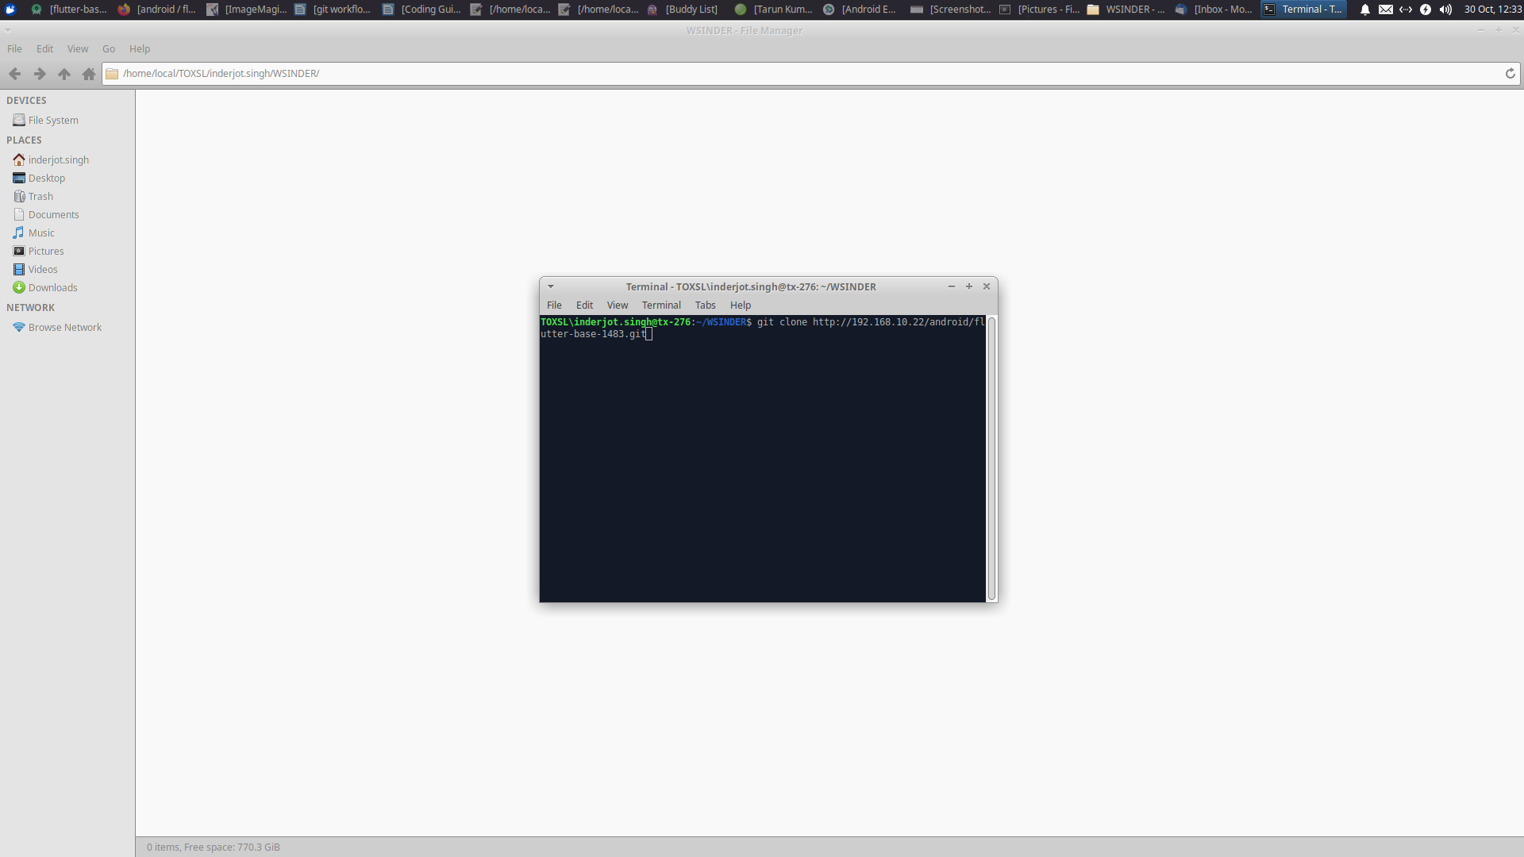
5. If project is new than clone the base project from Gitlab.

6. Copy the app folder of your base project and add it to the cloned project folder.
NOTE: Don’t use capital letters for your folder name.

7. Setup the project and change the package name of your project.

8. Use setting icon in project directory and click to compact empty middle packages option.

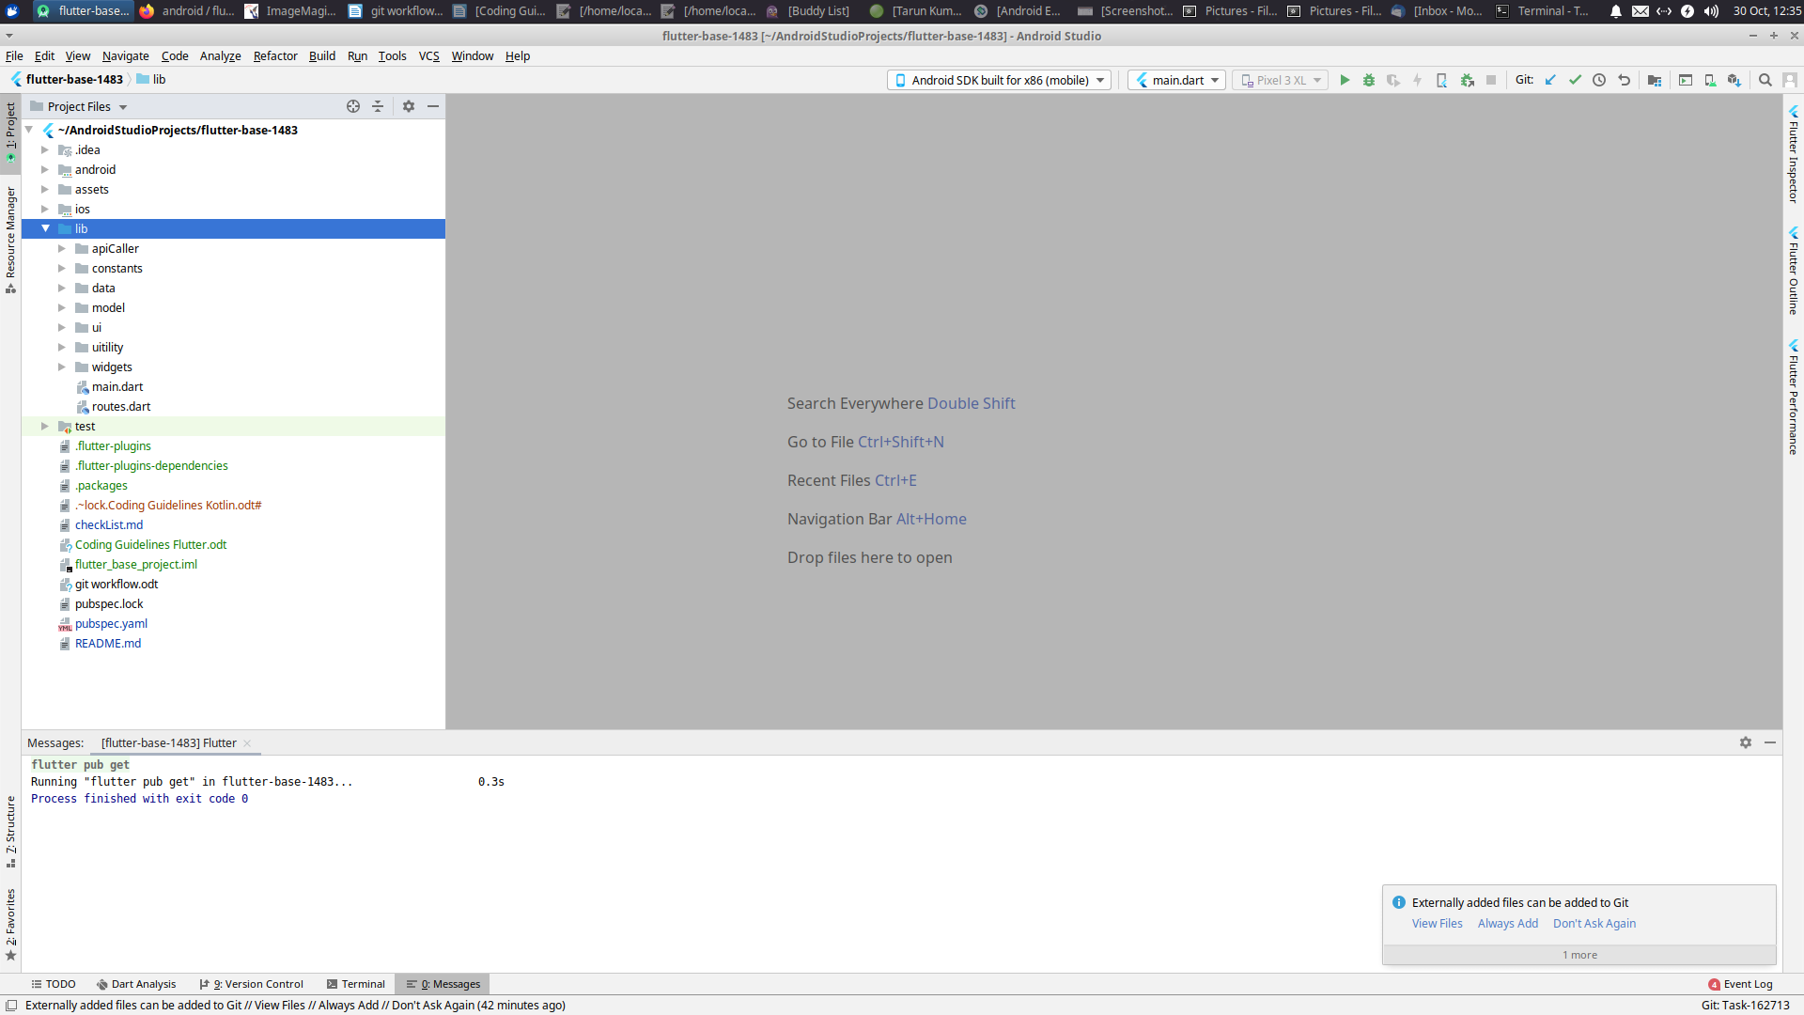

9. Replace your package name with older with the use of refactor.

10. Check if the old name exist in the application.

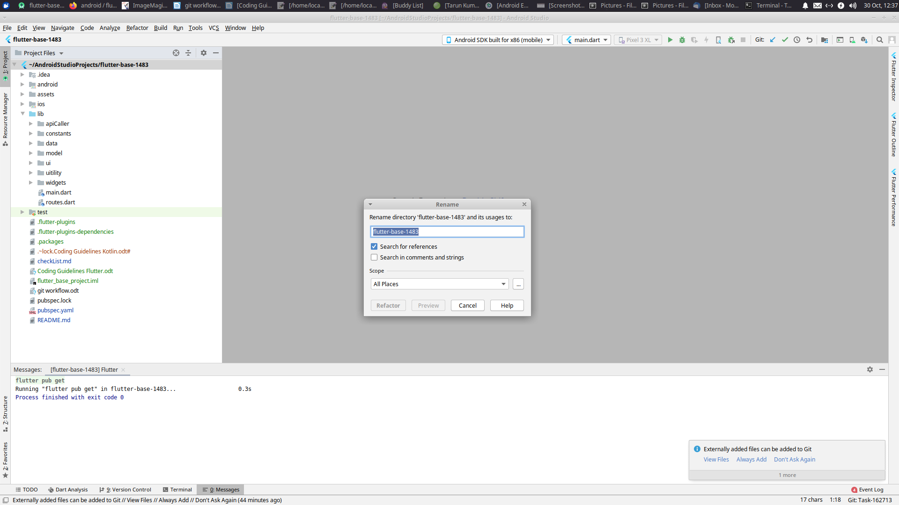

11. Don’t forget to change the application id in gradle file.

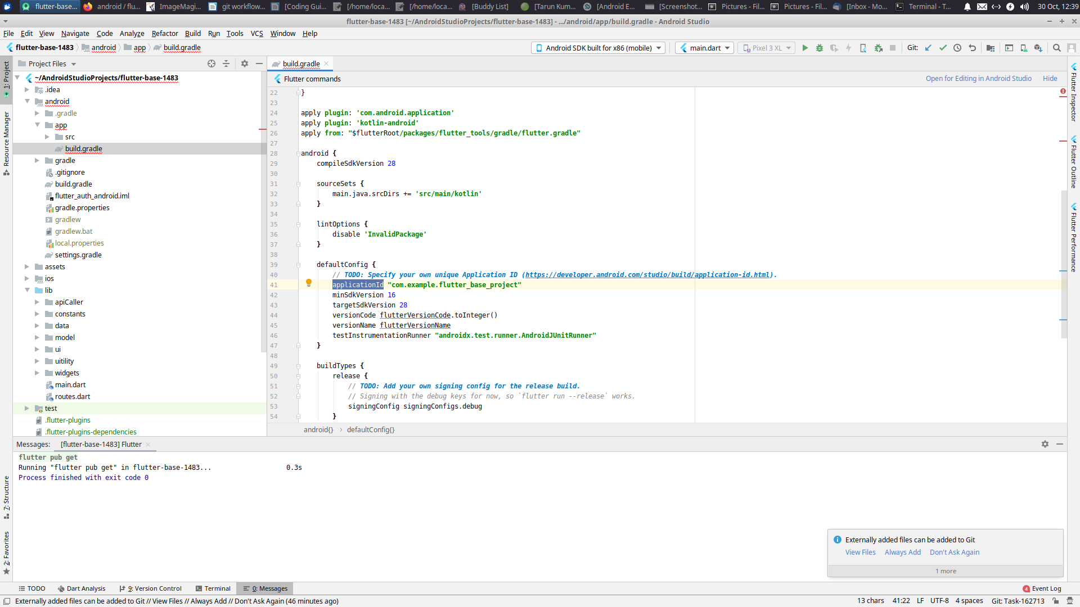

12. And run the project after setup and your are ready to work.
13. Checkout the dev branch other than hed branch i.e. master.

Click on the git:master link and select the New Branch option

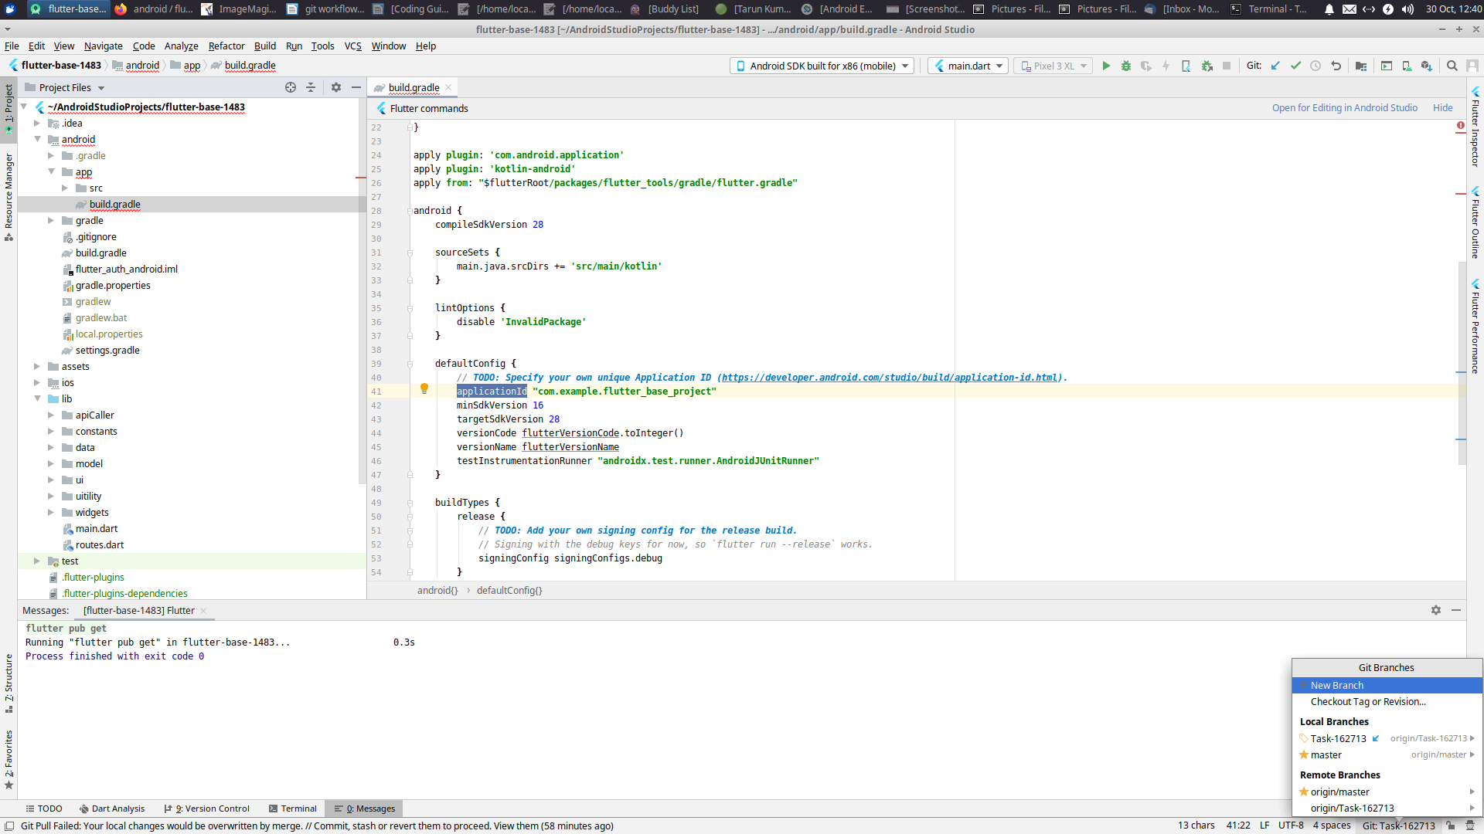
Add the branch name

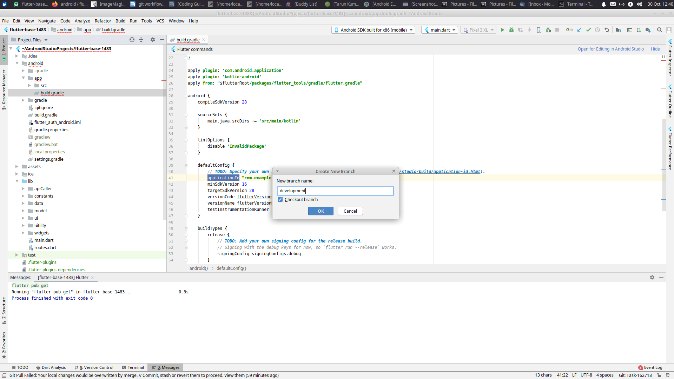

Now u need to add the module files except your libraries to git in the dev branch.

14. Now add the files to git and commit the changes.
15. Right click on the app folder and GIT → ADD
16. Right click on the app folder and GIT → Commit Directory
17. In the commit Screen copy the Task link from PROMIS and paste it into commit message.
Note: without this our commit wont be included.

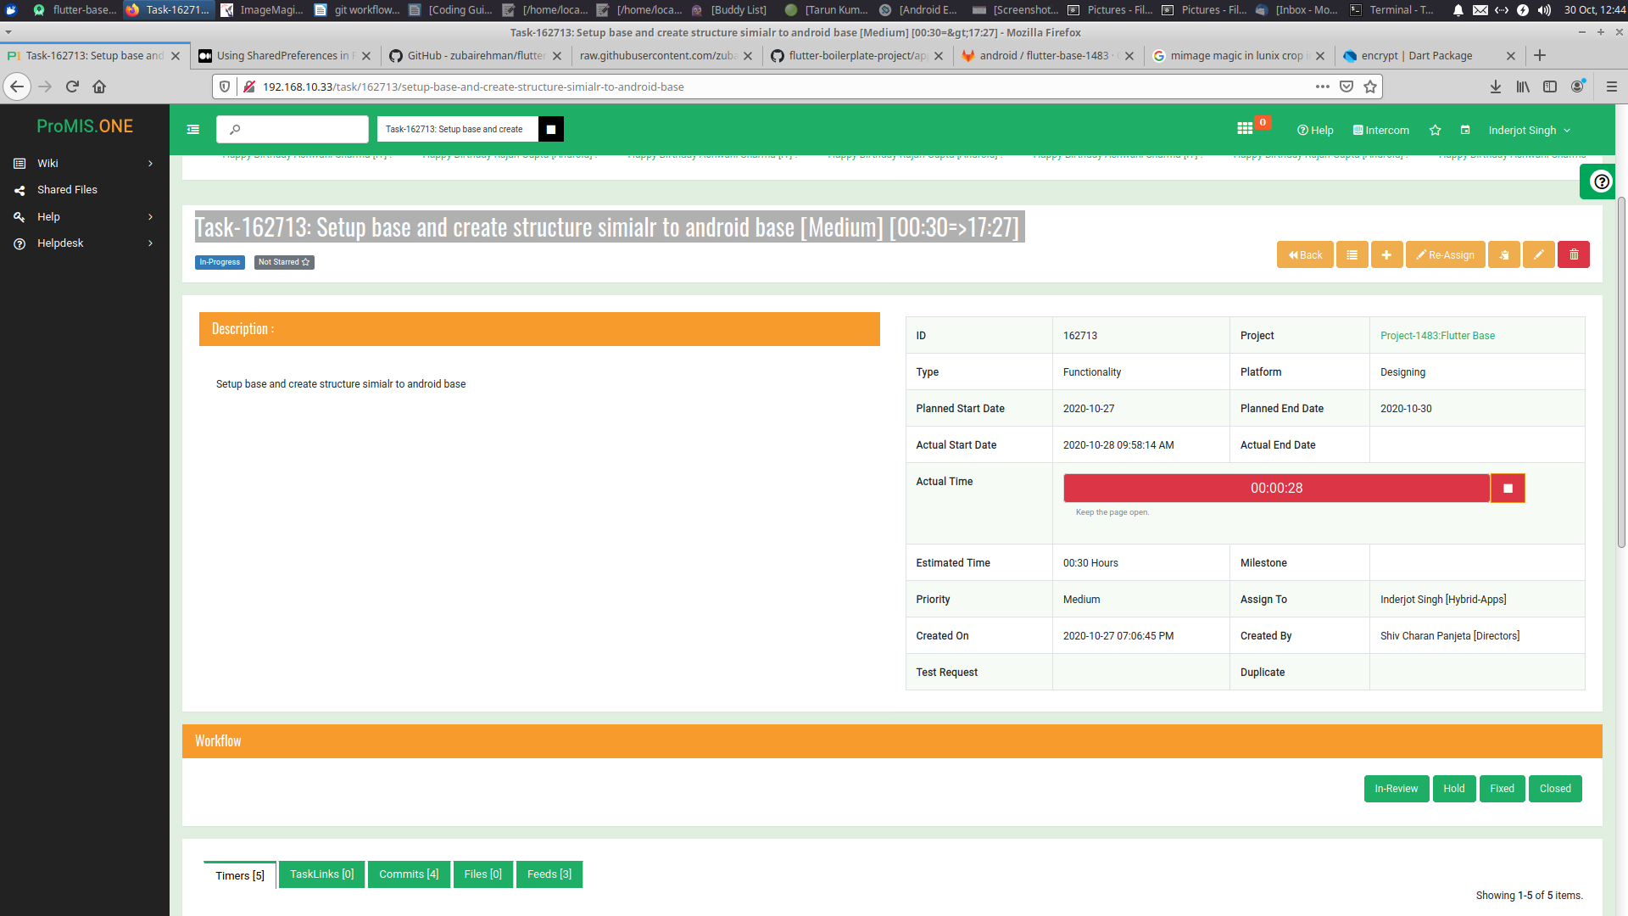
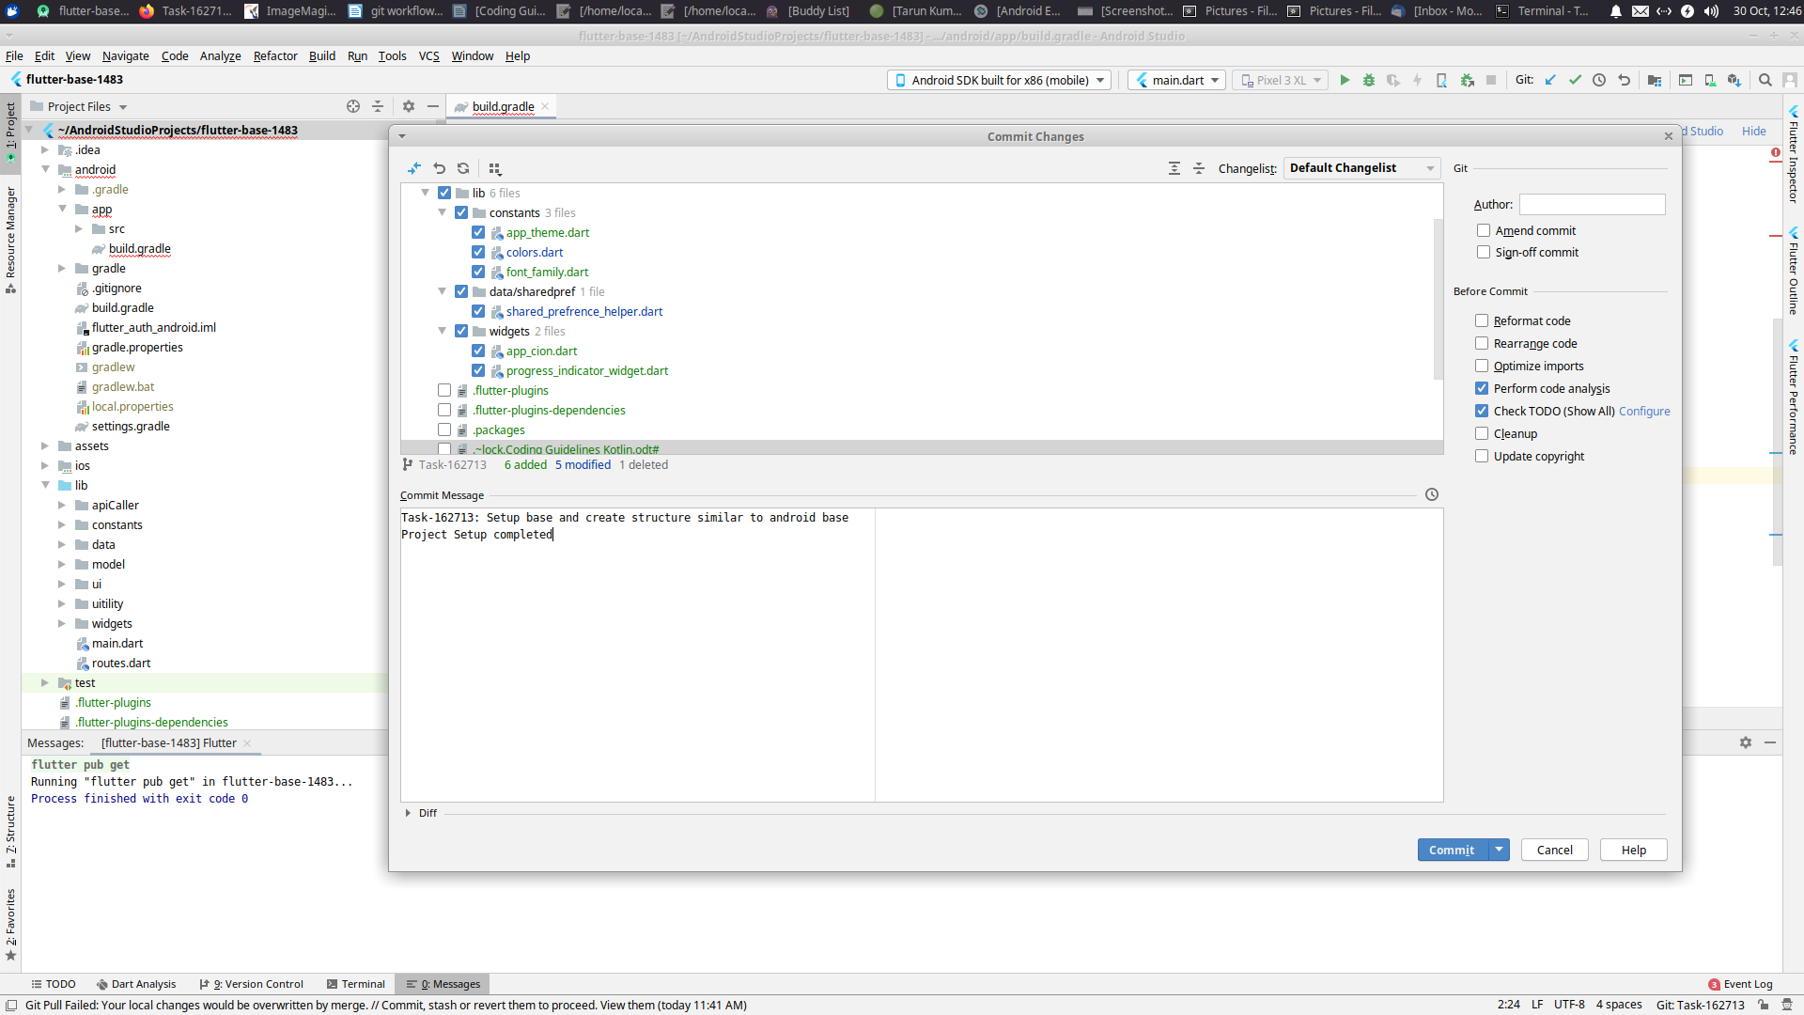

And now you can commit and push the changes to git.

18. When you are ready to push the data make sure you add your library files to .gitignore file.

19. After data is pushed you will be able to see two branch in the gitlab project.

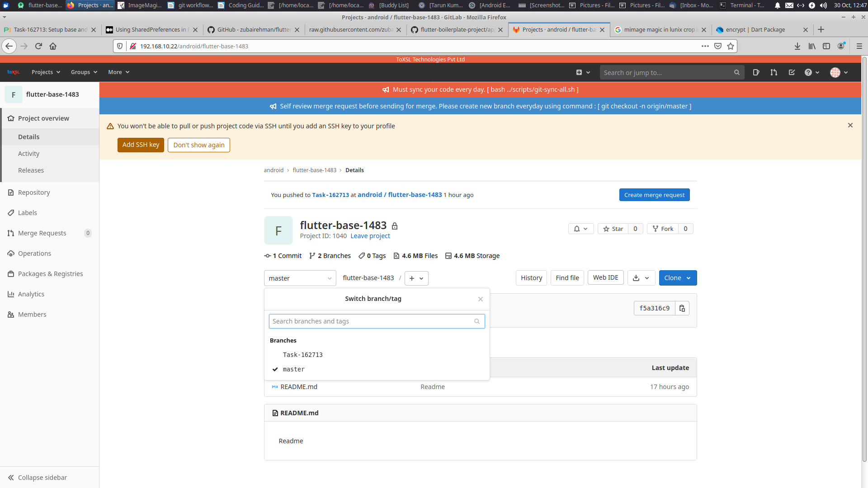

And there you go and start the development.

